BERLIN SKILL DEVELOPMENT
BASKETBALL CAMP

GANON BAKER 21 – 24 June
NBA Skill Development Coach ( 09.00 – 16.00) (Carl Zeiss Oberschule Lutherstr. 12305)

Co- operated with Coach Galanis Dimitrios
( Coaching in Russia-Greece-Bulgaria )

REGISTRATION: ZAPTIES DIMITRIOS
e Mail Basketballexelixis@yahoo.com
NAMES OF TEAMS CO-OPERATED:

The Coach who LeBron James, Steph Curry, Chris Paul, Kobe Byant & many stars of the ΝΒΑ trust for their Skill Improvement comes to BERLIN !!! This is GANNON BAKER, the #1 Skill Develpoment Coach in the World, Certified NBA Coach , with Clinics in 32 countries and more than 50 basketball educated DVDs.
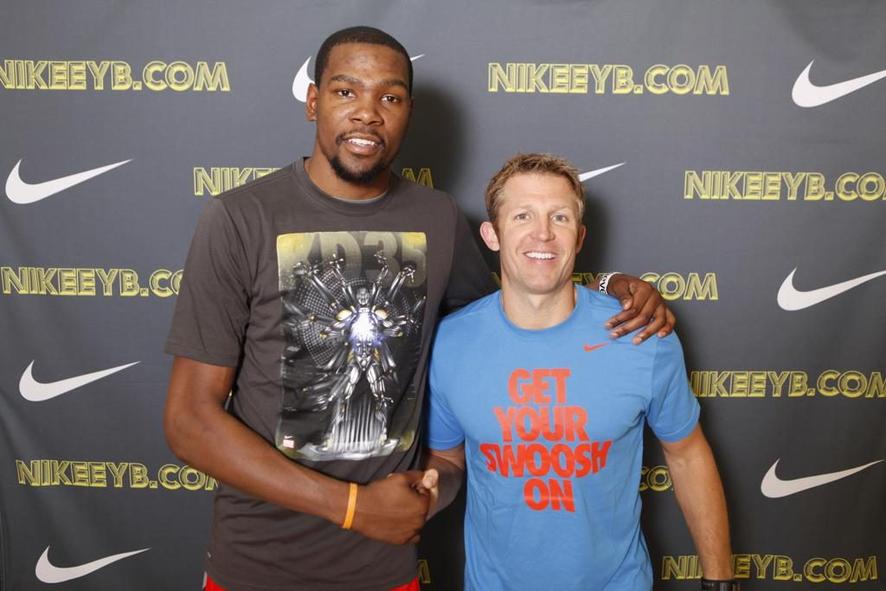2
With him as staff Coach Galanis ( Lukoil, Vostok65,Greek A1)
PROGRAM
FR 21/6. SA- SUN-MON (22-23-24/6)
8.15-9.30 REGISTRATION 8.45 PLAYERS ATTENDANCE
9.30-16.30 CAMP 9.00-16.00 CAMP
*For the very young kids we are going to have a teacher of ARTS as well
( to do things in breaks )
COST : BENEFITS
-200 euro by registration before 15/5 (230 euro after) - T-SHIRT
Deposit:100 euro - SNACK /DRINK
Only 120 seats available /Early Bird - GIFTS
- DIPLOMA
- 20 Hrs High Level Training

REGISTRATION

SURNAME:……………………………………………… FIRST NAME:…………………………………………

BORN YEAR:………………………………………………………….TEAM:……………………………………….

TEL : ……………………………………………………………….( PLAYER OR PARENT)
SIZE T-SHIRT : XL – L – S- XS -XXS ( CIRCLE)
**I DECLARE THAT I AGREE WITH THE PARTICIPATION OF MY SON/ DAUGHTER TO BERLIN SKILL DEVELOPMENT BASKETBALL CAMP . I ALSO DECLARE THAT MY CHILD HAS NO PROBLEM OF HEALTH AND I WILL BRING MEDICAL CONFIRMATION.

Name:…………………………………………………………. Berlin: …………………………(Unterschrift)

